NAAN MUDHALVAN PROJECT REPORT
ARASU ENGINEERING COLLEGE,KUMBAKONAM
SwiftShip Tracker
A Salesforce-Based Parcel Booking and Tracking System with Agentforce AI
Submitted by
Team ID: SWTID-2026-2459
Team Size: 4
Role | Name
Team Leader | Vinitha V
Team Member | G Raja Priya
Team Member | E Preethi
Team Member | M Priyanka

Platform: Salesforce Developer Edition | Agentforce | Prompt Builder | Flow Builder
Computer science and Engineering
Academic Year 2026-27

SWIFT SHIP TRACKER

User Story:
The SwiftShip Tracker is designed to provide a centralised Salesforce-based parcel management solution that enables customers to book parcels, track delivery status and manage shipments through an intuitive interface and conversational AI support. The system manages Parcel, Delivery, Sender and Receiver information using Salesforce custom objects and relationships. Flows automate parcel operations and notifications, while Agentforce AI and Prompt Builder enable customers to retrieve parcel information and interact with the system conversationally. Delivery agents can update parcel status in real time, while Experience Cloud, security controls, reports and dashboards provide secure customer access and operational visibility.

1. INTRODUCTION

1.1 Project Overview
The SwiftShip Tracker is a Salesforce CRM solution developed to simplify parcel booking, shipment tracking and delivery management. It supports the complete parcel lifecycle, from booking and dispatch through tracking and delivery confirmation. Customers can access shipment information, while delivery agents can update parcel details and delivery status.
The solution is built entirely on the Salesforce platform. Parcel, Delivery, Sender and Receiver information is stored in custom objects with relationships between them. Salesforce Flow automates the retrieval of parcel data, Prompt Builder defines how parcel information is presented, and Agentforce provides a conversational agent through which a user can ask for parcel details in plain language.

1.2 Purpose
The purpose of SwiftShip Tracker is to:
- Centralise parcel and delivery information.
- Simplify parcel booking and tracking.
- Provide real-time shipment visibility.
- Automate delivery updates and customer notifications.
- Enable conversational parcel tracking using Agentforce AI and Prompt Builder.
- Improve agent efficiency through Salesforce Flows and dashboards.
.

2. IDEATION PHASE

2.1 Problem Statement (Customer Problem Statement Template)
Five types of users were identified, and each one faces a different difficulty with the way parcels are handled today. The problem statements were captured using the customer problem statement template.
Table 1: Customer Problem Statements
PS | I am (Customer) | I am trying to | But | Because | Which makes me feel
PS-1 | Customer / Sender | book a parcel easily | booking requires support assistance or multiple applications | parcel operations are not centralised | frustrated
PS-2 | Customer / Sender | track my parcel | I do not have a simple real-time tracking experience | shipment information is difficult to access | confused
PS-3 | Delivery Agent | update parcel status | status updates require manual handling | there is a need for centralised operational tracking | concerned
PS-4 | Customer | receive delivery updates | notifications may not be available at every delivery stage | communication needs to be automated | uncertain
PS-5 | Admin | monitor parcel operations | parcel flow and delivery performance are difficult to monitor | operational data needs centralised reporting | concerned

2.2 Empathy Map Canvas
User Persona: Customer / Sender
- Think & Feel: Wants a simple, convenient and reliable way to book and track parcels without repeatedly contacting support. Hopes the parcel reaches on time and safely, and feels more confident with real-time updates.
- Hear: Receives delivery confirmations and status updates from the parcel service, information about delivery timelines, and feedback from friends, family or colleagues about their delivery experiences.
- See: Parcel details, tracking status, estimated delivery date, delivery information and notifications about shipment progress.
- Say & Do: Books parcels, checks tracking information regularly, asks for delivery updates and shares tracking information with recipients.
- Pain: Delays, confusion due to lack of clear tracking information, difficulty accessing shipment details, and dependence on support or multiple apps.
- Gain: Real-time visibility, self-service tracking, convenient booking, timely notifications and peace of mind knowing the parcel is on track.

2.3 Brainstorming & Idea Prioritization

Ideas Considered
Table 2: Ideas Considered
Idea | Description | Limitation
Manual registers | Maintain parcel and delivery details by hand. | Time-consuming and prone to errors.
Spreadsheet tracking | Track bookings, status and delivery information using spreadsheets. | Limited collaboration and scalability.
Standalone parcel portal | Develop a separate parcel booking and tracking portal. | Requires additional development, maintenance and infrastructure.
Salesforce CRM with AgentForce AI | Centralised management, tracking, automation and AI-based customer assistance. | Needs initial configuration effort (selected solution).

Final Selection
Salesforce CRM was selected due to:
- Centralised parcel management
- Automation through Flows
- Real-time tracking visibility
- Conversational AI assistance
- Secure role-based access
- Reports and dashboards

3. REQUIREMENT ANALYSIS PHASE

3.1 Customer Journey Map
Stages: Parcel Booking, Parcel Record Creation, Dispatch & Shipment, In-Transit Tracking, Out for Delivery, Delivery Confirmation, Customer Notification and Feedback / Support. The journey from booking to delivery, together with the customer's thoughts and emotions at each step, is summarised below.
Table 3: Customer Journey Map
Stage | What happens | Customer emotion
Parcel Inquiry | Customer checks parcel details, pricing and delivery options | Curious
Parcel Booking | Customer books a parcel by providing sender, receiver and parcel details | Happy
Record Creation | System creates a parcel record in Salesforce | Confident
Dispatch | Parcel is picked up and dispatched from the origin location | Satisfied
In-Transit Tracking | Parcel is in transit and can be tracked in real time | Reassured
Out for Delivery | Parcel is out for delivery to the receiver's location | Anticipated
Delivery Confirmation | Parcel is delivered successfully | Delighted
Customer Notification | Customer receives notifications at every stage | Informed
Reporting | Data is captured for reporting and performance analysis | Satisfied

3.2 Solution Requirements

Functional Requirements
Table 4: Functional Requirements
FR No | Requirement
FR-1 | Parcel booking and record creation
FR-2 | Parcel status tracking
FR-3 | Weight management
FR-4 | Estimated delivery date management
FR-5 | Sender information management
FR-6 | Receiver information management
FR-7 | Delivery and current-location tracking
FR-8 | Agent parcel status updates
FR-9 | Automated customer notifications
FR-10 | AI-powered parcel tracking
FR-11 | Reports and dashboards
FR-12 | Customer access through Experience Cloud

Non-Functional Requirements
Table 5: Non-Functional Requirements
NFR | Description
Usability | Intuitive Salesforce and customer-facing interface
Security | Role-based and field-level access control
Reliability | Accurate parcel status and delivery information
Performance | Timely Flow and AgentForce responses
Availability | Salesforce cloud-based access
Scalability | Supports growing parcel and delivery operations
Data Integrity | Controlled access and relationship-based parcel data
Maintainability | Flows, prompts, topics and configurations can be updated

3.3 Data Flow Diagram
Flow:
- Customer / Sender books a parcel (Parcel Booking).
- A Parcel Record is created.
- Sender and Receiver information is linked.
- A Delivery Record is created.
- The Parcel Status is updated.
- Current Location and Estimated Delivery are maintained.
- Automated Notifications are sent.
- The customer tracks the parcel directly or through AgentForce AI.
- Reports and Dashboards present the operational data.
AI Tracking Flow:
Customer Query, then AgentForce AI, then Prompt Builder (Retrieve Parcel Details), then the Parcel Record, then Status / Weight / Estimated Delivery, and finally a Conversational Response. The Prompt Builder implementation retrieves Parcel ID, Status, Weight and Estimated Delivery Date information for tracking responses.

3.4 Technology Stack
Table 6: Technology Stack
Layer | Technology
Platform | Salesforce Developer Edition
UI | Lightning App Page, Lightning Record Pages, Experience Cloud
Database | Salesforce Custom & Standard Objects
Business Logic | Salesforce Flows, Apex Classes
Automation | Record-Triggered Flows, Auto-Launched Flows, Scheduled Flows
AI | AgentForce AI, Prompt Builder
Notifications | Email Alerts & Email Templates
Processing | Batch Apex
Security | Profiles, Permission Sets, Role Hierarchy, Field-Level Security, Sharing Rules
Reporting | Reports & Dashboards

4. PROJECT DESIGN PHASE

4.1 Problem–Solution Fit
Table 7: Problem–Solution Fit
Problem | Solution | Benefit
Parcel booking is difficult | Salesforce Parcel management | Centralised booking
Tracking requires support | AgentForce AI + Prompt Builder | Self-service tracking
Manual status updates | Salesforce Flows | Automated processes
Delivery communication gaps | Email Alerts | Timely notifications
Scattered shipment information | Parcel, Delivery, Sender & Receiver objects | Structured data
Difficult operational monitoring | Reports & Dashboards | Better visibility
Different users need different access | Profiles, Roles & Permission Sets | Secure access

4.2 Proposed Solution
Table 8: Proposed Solution
Parameter | Description
Problem | Difficult and inefficient parcel booking and tracking
Solution | Salesforce-based Parcel Management System
Innovation | AgentForce AI + Prompt Builder for conversational self-service tracking and automated Salesforce Flows
Impact | Centralised booking, real-time tracking visibility, timely notifications and efficient delivery management
Business Model | Parcel, customer, delivery-agent, support and administrator operations
Scalability | Supports growing parcel operations, Experience Cloud and integration with external logistics systems

4.3 Solution Architecture
The architecture is layered. Users (Customer, Delivery Agent, Support Staff and Admin) reach the SwiftShip Tracker through Salesforce Lightning or Experience Cloud. Inside the Salesforce platform there are four cooperating layers.
- Data Layer: Parcel, Delivery, Sender and Receiver custom objects.
- Automation Layer: Flows, Approval Processes, Apex Classes, Batch Apex and Email Alerts.
- AI Layer: AgentForce AI, Prompt Builder and the Parcel Tracking Agent.
- Security Layer: Profiles, Roles, Permission Sets, Sharing Rules and Field-Level Security.
On top of these layers, Reports & Dashboards provide Parcel Tracking and Operational Insights.

5. PROJECT PLANNING & SCHEDULING

5.1 Project Planning
- Agile methodology
- Epics → Stories → Story Points
- Sprint-based execution
- Velocity calculation used for estimation
Product Backlog, Sprint Schedule, and Estimation
Table 9: Product Backlog
Sprint | Functional Requirement (Epic) | User Story Number | User Story / Task | Story Points | Priority | Team Members
Sprint-1 | Developer Setup | USN-1 | As a system administrator, I want to create and configure the Salesforce environment so that I can build the SwiftShip Tracker parcel management system. | 3 | High | Member1
Sprint-2 | Data Modeling | USN-2 | As an admin, I want to create Parcel, Delivery, Sender and Receiver objects with proper relationships so that parcel and delivery data is stored and managed systematically. | 5 | High | Member2
Sprint-2 | Data Modeling | USN-3 | As a staff member, I want dedicated tabs and a Lightning App for SwiftShip modules so that I can easily navigate and manage parcel and delivery operations. | 5 | High | Member3
Sprint-3 | Automation | USN-4 | As a system, I want to validate parcel details, mandatory fields and booking inputs so that invalid or incomplete parcel records are prevented. | 3 | High | Member4
Sprint-3 | Automation | USN-5 | As a delivery coordinator, I want automated Flows to update parcel status and delivery information so that parcel processing requires minimal manual effort. | 3 | High | Member4
Sprint-4 | Apex | USN-6 | As a system, I want Apex triggers and classes to automatically perform critical parcel and delivery actions so that important processes are handled accurately. | 5 | High | Member1
Sprint-4 | Apex | USN-7 | As an operations manager, I want Batch Apex jobs to process and update parcel or delivery records automatically so that operational data remains accurate. | 5 | High | Member2
Sprint-5 | Reports | USN-8 | As a manager, I want reports showing parcel status, delivery performance and operational metrics so that I can monitor operations and make informed decisions. | 4 | High | Member3
Sprint-6 | Dashboards & AI | USN-9 | As a manager, I want dashboards showing parcel status and key metrics, while Agentforce provides AI-powered tracking assistance, so that I can monitor operations efficiently. | 4 | Medium | Member4

Project Tracker, Velocity & Burndown Chart
Table 10: Sprint Tracker
Sprint | Total Story Points | Duration | Sprint Start Date | Sprint End Date (Planned) | Story Points Completed | Sprint Release Date (Actual)
Sprint-1 | 3 | 6 Days | 24 Aug 2026 | 29 Aug 2026 | 3 | 29 Aug 2026
Sprint-2 | 10 | 6 Days | 31 Aug 2026 | 05 Sep 2026 | 10 | 05 Sep 2026
Sprint-3 | 6 | 6 Days | 07 Sep 2026 | 12 Sep 2026 | 6 | 12 Sep 2026
Sprint-4 | 10 | 6 Days | 14 Sep 2026 | 19 Sep 2026 | 10 | 19 Sep 2026
Sprint-5 | 4 | 6 Days | 21 Sep 2026 | 26 Sep 2026 | 4 | 26 Sep 2026
Sprint-6 | 4 | 6 Days | 28 Sep 2026 | 03 Oct 2026 | 4 | 03 Oct 2026

The total backlog is 37 story points over 6 sprints, so the average velocity is 37 / 6, which is about 6.2 story points per sprint. All planned stories were completed within their sprint durations.

6. PROJECT DEVELOPMENT PHASE

Phase 1: Requirement Analysis & Planning
Objective:
Customers often face delays and confusion while booking, tracking and managing parcel deliveries because they need to call support or use multiple apps. A conversational AI agent can simplify this by allowing customers to book parcels, get live tracking and manage deliveries in one place.
Key Requirements:
- Requirement gathering from end users and delivery agents.
- Defining system scope and user personas (Customer, Agent, Admin).
- Designing the data model with relationships between Parcel, Sender, Receiver and Delivery.
- Identifying use cases such as parcel booking, tracking and delivery update automation.
- Selecting tools: Salesforce Flows, Prompt Builder and AgentForce AI.

Defining Project Scope & Objectives
Project Scope:
- Build a scalable CRM solution for parcel delivery businesses to manage customer bookings, shipments and delivery operations efficiently.
- Support the end-to-end parcel lifecycle: parcel booking, dispatch, tracking and delivery confirmation.
- Include comprehensive data model design, automation (Flows, Apex, Email Alerts), AI-powered Prompt Builder and reporting dashboards for effective management.
- Provide role-based access for admins, delivery agents and customers through Salesforce profiles, permission sets and Experience Cloud.
- Ensure real-time parcel visibility for customers and simplified operational tracking for agents through AI-integrated conversational support.
Objectives Summary:
- Streamline parcel operations by automating booking, tracking and delivery notifications to reduce manual updates.
- Improve customer satisfaction with transparent, real-time shipment status and self-service tracking options.
- Enhance agent efficiency through centralised dashboards and guided Flows for quick status updates.
- Enable business insights with reports and dashboards showing parcel trends, delivery performance and agent activity.
- Ensure security and reliability by implementing role hierarchies, sharing rules and audit-based data access.

Gathering & Analysing User Needs
Users Involved:
- Customers / Senders: end users who book parcels, track deliveries and receive real-time updates through the portal or AI agent.
- Delivery Agents: manage assigned parcels, update delivery status and ensure timely handover to customers.
- Customer Support Team: handle delivery-related issues, respond to customer queries and ensure smooth communication.
- Admin Team: configure the Salesforce environment, manage user roles and security settings, and monitor operational performance.
- System Integrator / Developer: implement automation, AI agent setup and backend integrations.
Key Functional Needs:
- Seamless parcel booking and tracking interface for customers through a Salesforce Experience Site or agent assistance.
- Ability for agents to update parcel status (Booked, In Transit, Out for Delivery, Delivered) in real time.
- Automated notifications and email alerts to customers on every delivery stage update.
- Support for Sender and Receiver details management with address, contact and email fields.
- AI agent integration (via Prompt Builder) for real-time parcel status queries and automated assistance.
- Reports and dashboards to monitor parcel flow, delivery performance and agent activity for admins.
- Security controls with role-based access, profiles and permission sets for different user levels.
Tools Used:
- Salesforce Developer Org for configuration, development and testing.
- Prompt Builder (AgentForce AI) to create intelligent parcel tracking prompts and responses.
- Salesforce Flow Builder to automate booking, tracking and delivery updates.
- Google Sheets / Docs for initial data planning, requirement documentation and system mapping.

Identifying Key Salesforce Features & Tools Required
- Custom Objects: Parcel__c, Delivery__c, Sender__c, Receiver__c.
- Standard Objects: Account, Contact, Case, Task, EmailMessage, User.
- Automations: Record-Triggered Flows, Auto-Launched Flows, Approval Processes, Scheduled Flows.
- Apex: Apex Classes for automated parcel operations, Batch Apex for periodic updates or notifications.
- UI: Lightning App Page, Dynamic Forms for parcel details, Lightning Record Pages and Experience Cloud for customer access.
- AgentForce AI & Prompt Builder: integrated AI agent trained to fetch parcel data based on Parcel ID and respond to tracking or delivery status queries.
- Email Services: custom Email Alerts and Templates for booking confirmations, delivery updates and completion acknowledgements.
- Security: Profiles, Permission Sets, Role Hierarchies, Field-Level Security and Sharing Rules for controlled access.

Designing Data Model and Security Model
Data Model Includes:
- Parcel__c: stores core parcel details such as Parcel ID, Status, Weight and Estimated Delivery Date; linked to Sender__c and Receiver__c; connected with Delivery__c to track location and status.
- Delivery__c: stores delivery-specific information such as current location, estimated delivery date and the linked parcel; used by agents to update and monitor delivery status.
- Sender__c: captures sender address, contact number and email; linked to multiple parcels to track sender history; used for booking confirmations and delivery update e-mails.
- Receiver__c: stores receiver address, contact and email; linked to Sender__c and Parcel__c; used for delivery reference and e-mail notifications upon completion.
Security Model Design:
- Role Hierarchy: Administrator, Delivery Manager, Agent, Customer.
- Profiles: Admin has full access; Delivery Agent has read and edit access to Parcel, Delivery, Sender and Receiver; Customer has read-only access to their own parcel details via Experience Cloud; Support Staff can access Cases and parcel details.
- Permission Sets: grant additional privileges such as "Update Delivery Status" or "Access Agent Console".
- Record-Level Security: sharing rules on Parcel__c and Delivery__c for controlled access; customers can only view records linked to their own Sender or Receiver details.
- Field-Level Security: sensitive fields such as Sender Email, Receiver Contact and Location Coordinates are restricted to Admin and Agent profiles.

Phase 2: Salesforce Development – Backend & Configurations
This phase focused on developing the core logic of SwiftShip Tracker. Custom objects were created for Parcel, Sender, Receiver and Delivery with relationships. A prompt template, an autolaunched flow and an Agentforce agent were then built on top of them.

Milestone 1 - Salesforce Account
Salesforce is a customer success platform designed to help organisations sell, service, market, analyse and connect with customers. To begin, a free Developer Edition organisation was created at https://developer.salesforce.com/signup using the first name, last name, e-mail, job title Developer, company (college name) and country India. After clicking Sign Me Up, the verification e-mail was opened, Verify Account was clicked, and a password and security question were set. The user was then redirected to the Salesforce Setup page. Figure 1 shows the Setup Home page of the organisation used for this project.
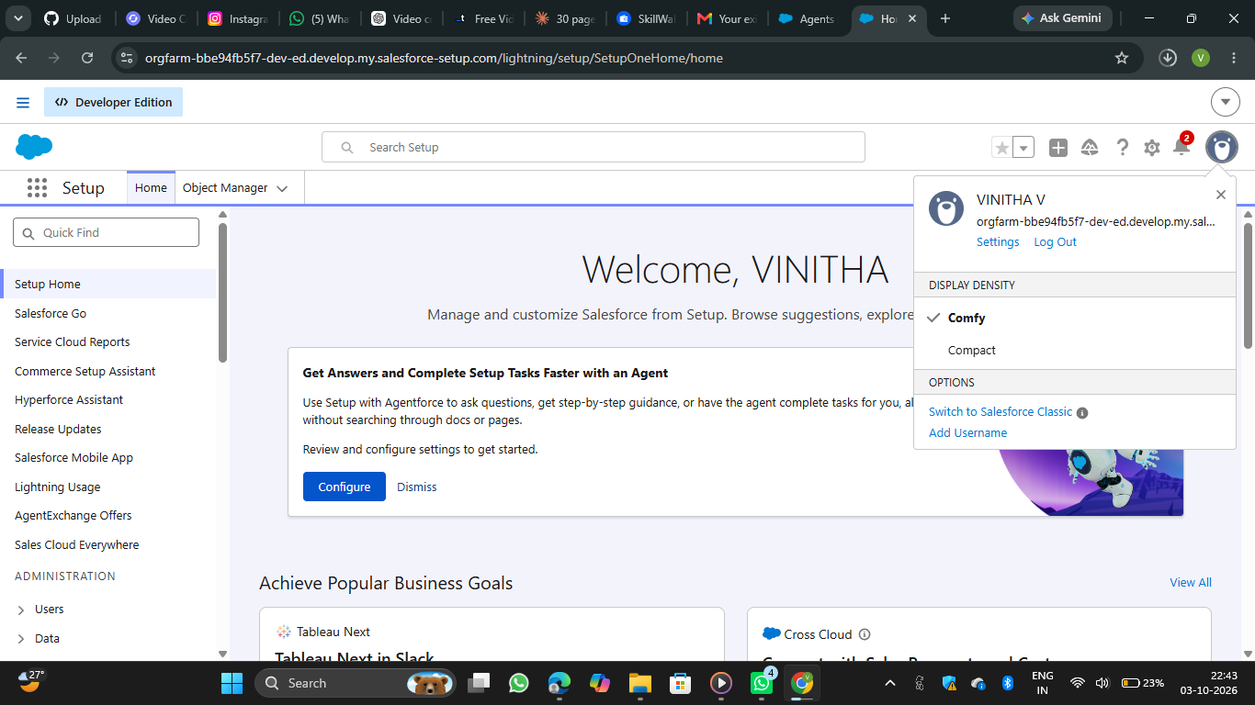
Figure 1: Salesforce Setup Home page of the Developer Edition organisation

Milestone 2 - Objects Creation
To create an object: from the Setup page, click Object Manager, then Create, then Custom Object. Enter the label name (for example Parcel), the plural label name (Parcels) and the record name (Parcel Name), with the data type Text. Select Allow Reports, Allow Search and Track Field History, and click Save. The same steps were repeated for the other objects.
Table 11: Custom Objects Created
Object | Plural label | Record name | API name
Parcel | Parcels | Parcel Name | Parcel__c
Delivery | Deliveries | Delivery Name | Delivery__c
Sender | Senders | Sender Name | Sender__c
Receiver | Receivers | Receiver Name | Receiver__c

Figure 2 shows the details page of the Parcel object. The API name is Parcel__c, the object is custom, Enable Reports, Track Activities and Track Field History are ticked, and the deployment status is Deployed.
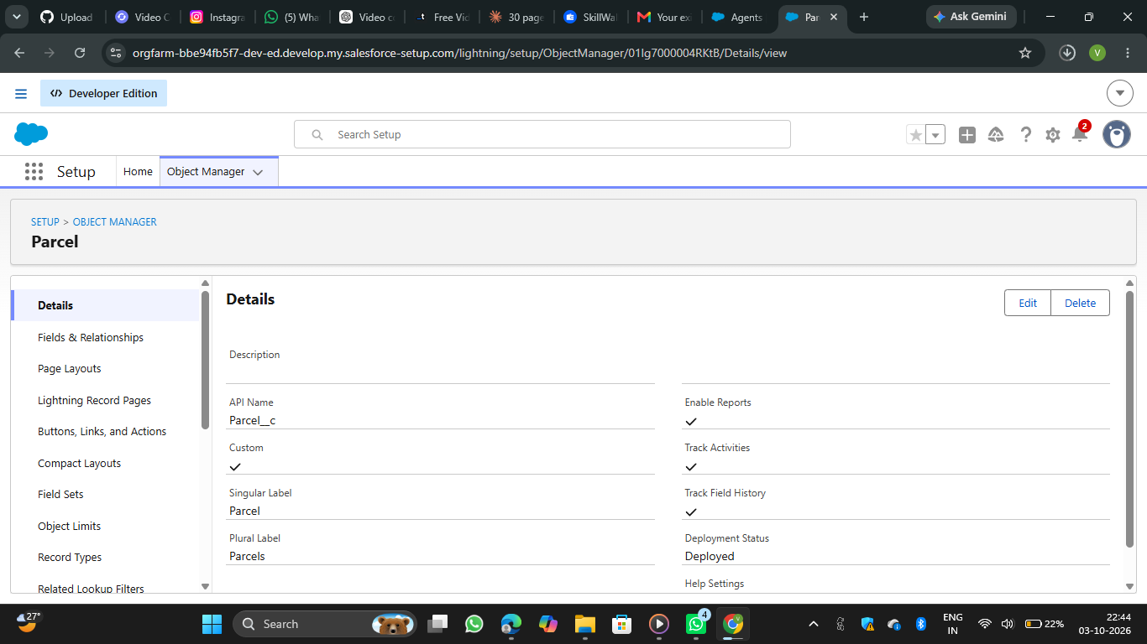
Figure 2: Parcel object details in Object Manager

Milestone 3 - Tabs
A tab was created for each custom object. Go to Setup, type Tabs in the Quick Find bar, click Tabs and then New under Custom Object Tabs. Select the object (Parcel, Delivery, Sender or Receiver), choose a tab style, click Next to keep the Add to Profiles settings as default, and on the Add to Custom App page uncheck Include Tab. Make sure "Append tab to the user's existing personal customizations" is checked, and click Save.
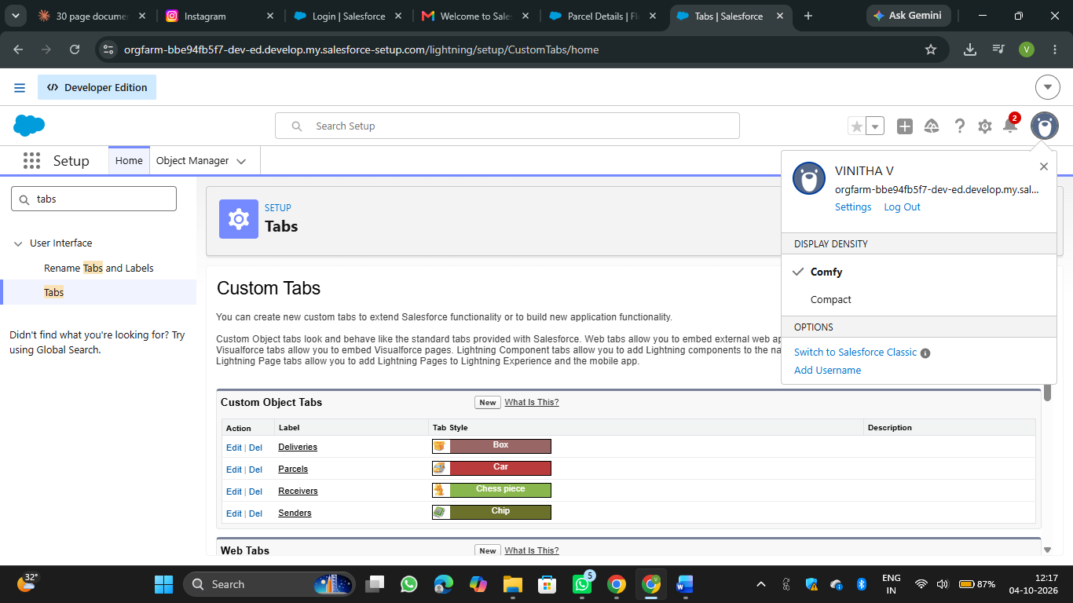

Milestone 4 - Fields & Relationships
Fields and relationships were created for each object from Object Manager, Fields & Relationships, New. For the Parcel object, the first field is Parcel ID with the data type Auto Number and the display format P-{000}. The remaining fields (Status, Weight, Estimated Delivery and Sender) were created in the same way. Figure 3 shows the field list of the Parcel object, including Parcel ID (Auto Number, API name Parcel_ID__c) and Estimated Delivery (Date, API name Estimated__c).
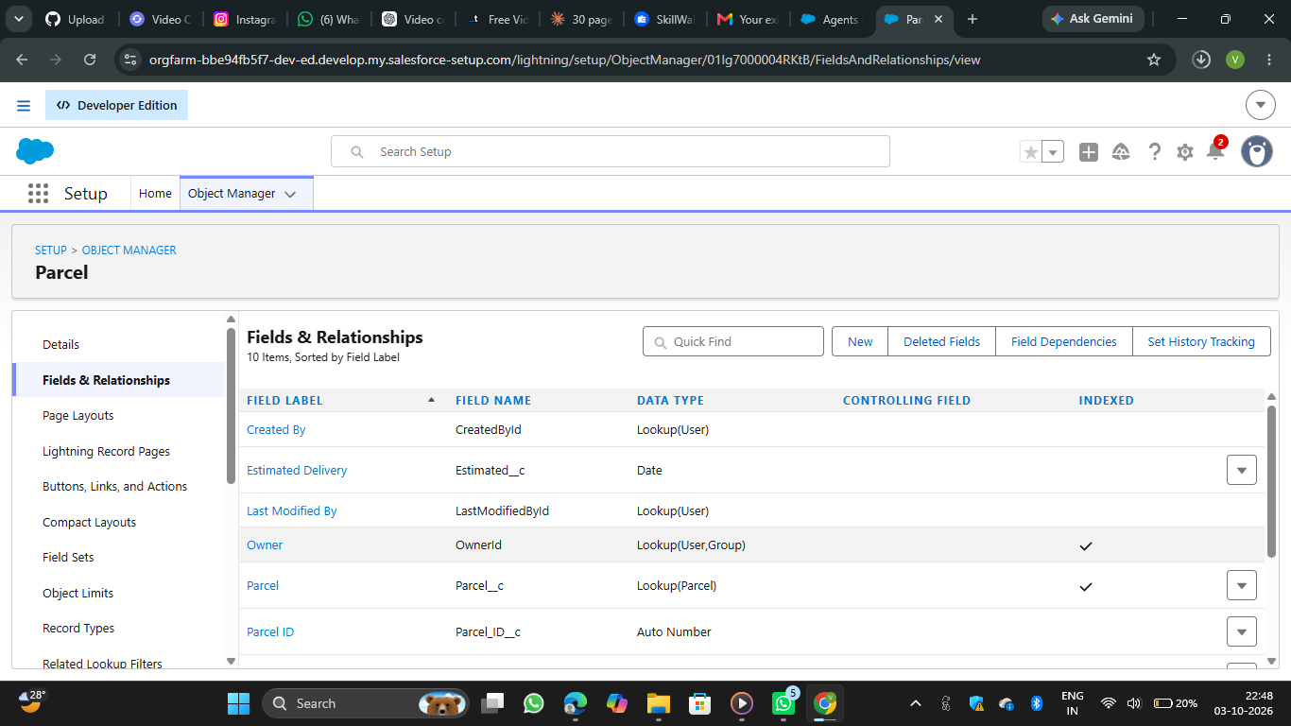
Figure 3: Fields & Relationships of the Parcel object
Table 12: Parcel Object Fields
Field Name | API Name | Data Type | Description
Parcel ID | Parcel_ID__c | Auto Number | Unique ID for each parcel
Status | Status__c | Picklist | Booked, In Transit, Out for Delivery, Delivered
Weight | Weight__c | Number | Weight of parcel
Estimated Delivery | Estimated__c | Date | Expected delivery date
Sender | Sender__c | Lookup Relationship | Gets details from Sender

For the Delivery object, the field Current Location was created with the data type Geolocation, followed by Estimated Delivery, Sender and Parcel.
Table 13: Delivery Object Fields
Field Name | Data Type | Description
Current Location | Geolocation | Location in terms of longitude and latitude
Estimated Delivery | Date | Expected delivery date
Sender | Lookup Relationship | Gets details from Sender
Parcel | Lookup Relationship | Gets details from Parcel

For the Sender object, the field Sender Address was created as Geolocation, then Sender Contact and Sender Email. For the Receiver object, Receiver Address was created as Geolocation, then Receiver Contact, Receiver Email, Sender and Parcel.
Table 14: Sender and Receiver Object Fields
Object | Field Name | Data Type | Description
Sender | Sender Address | Geolocation | Location in terms of longitude and latitude
Sender | Sender Contact | Phone | To contact the sender
Sender | Sender Email | Email | To send e-mail notification
Receiver | Receiver Address | Geolocation | Location in terms of longitude and latitude
Receiver | Receiver Contact | Phone | To contact the receiver
Receiver | Receiver Email | Email | To send e-mail notification
Receiver | Sender, Parcel | Lookup Relationship | Gets details from Sender and Parcel

Milestone 5 - Prompt Builder
Prompt Builder was used to design the prompt for agent building. In Salesforce Setup, Prompt Builder was opened (Quick Find, Prompt Builder), and New Prompt Template was clicked with the template type Record Summary and the object type Parcel. The details were entered as follows.
- Label: Retrieve Parcel Details
- API Name: Retrieve_Parcel_Details
- Description: Retrieves parcel details where Parcel ID matches the user input.
In the prompt template text area, the instruction was written to retrieve details from Parcel__c where Parcel_ID__c matches the user input and to return the response in a "Parcel Tracking Update" format with the Parcel Name, Parcel ID, Status, Weight and Estimated Delivery Date. Each value was inserted as a resource of the Parcel object using Insert Resource. The template uses the Standard model type with the GPT 5 Mini model. The template was then saved and activated so that it is available to agents and flows. Figure 4 shows the active template.
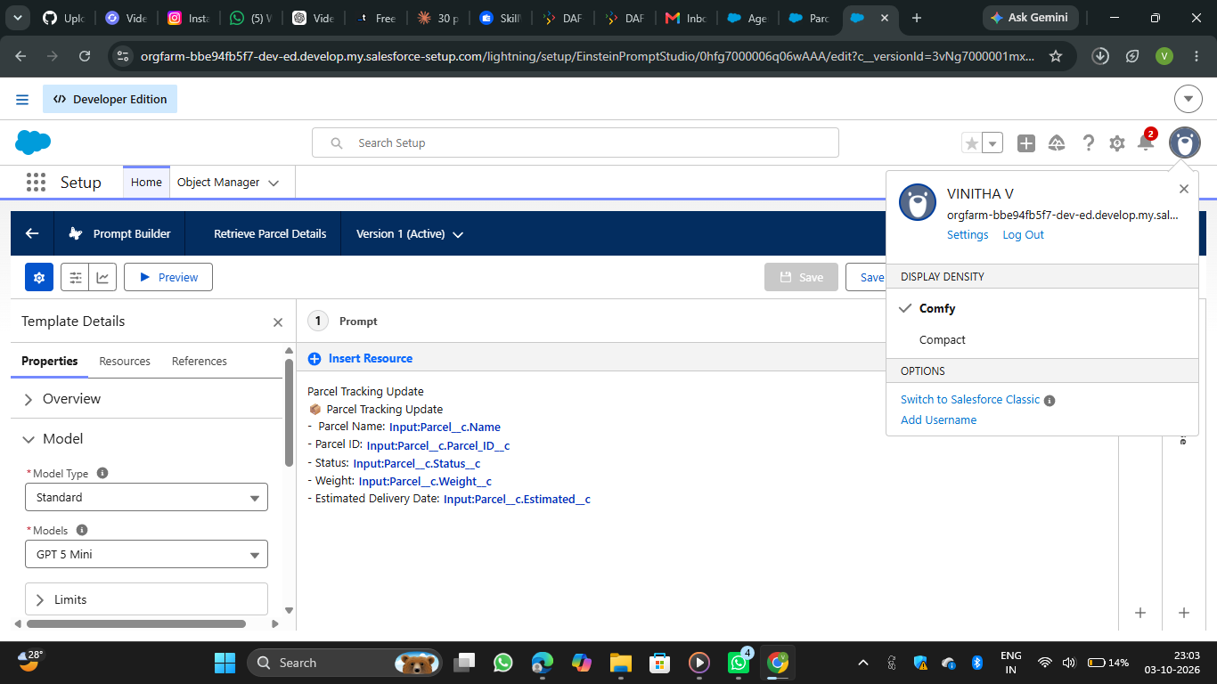
Figure 4: Prompt Builder template "Retrieve Parcel Details" (Version 1, Active)

Milestone 6 - Flows
A flow was created for capturing the response. Go to Setup, search Flows and click New Flow. Choose Autolaunched Flow (No Trigger) and click Create. The following steps were carried out.
- Add input variables to allow the agent to pass values. Click New Resource, then Variable. The variable "ids" has the data type Text and is available for input. The variable "output" has the data type Text and is available for output.
- Add a Get Records element with the label "get parcel records". The object is Parcel, the field is Parcel ID, the operator is Equals and the value is "ids".
- Add an Action element. Find and select the prompt template "Retrieve Parcel Details", give the label "Parcel Updates" and set the Object to Summarize as the Parcel from get parcel records.
- Add an Assignment element with the label "assignment output". The variable is "output", the operator is Equals and the value is the Prompt Response from the Action outputs.
- Connect Start, Get Records, Action, Assignment and End. Save the flow with the name "Parcel Details" and activate it.
- Go back to the flow list, open the drop-down near the new flow, choose Edit Access, and assign the required profiles under Flow User Access.
Figure 5 shows the Flows list in Agentforce Studio, where Parcel Details appears as an Autolaunched No Trigger Flow with the status Activated.
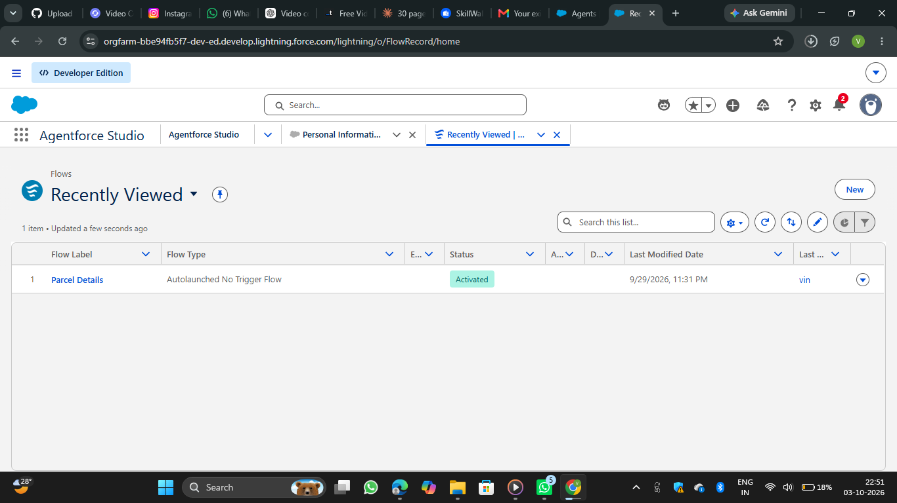
Figure 5: Flows list showing the activated "Parcel Details" flow

Phase 3: UI/UX Development & Customization
The aim of this phase is to enable agents to manage parcel operations efficiently and to ensure secure access control using permission sets and AI-driven agent experiences built with AgentForce.

Milestone 1 - Creating Permission Sets
In the Quick Find box, type Permission Sets and click Permission Sets under Users. Click New and enter the label "Swift Ship"; the API name auto-fills as Swift_Ship. Choose the license Einstein Agent and click Save. Figure 6 shows the permission set overview.
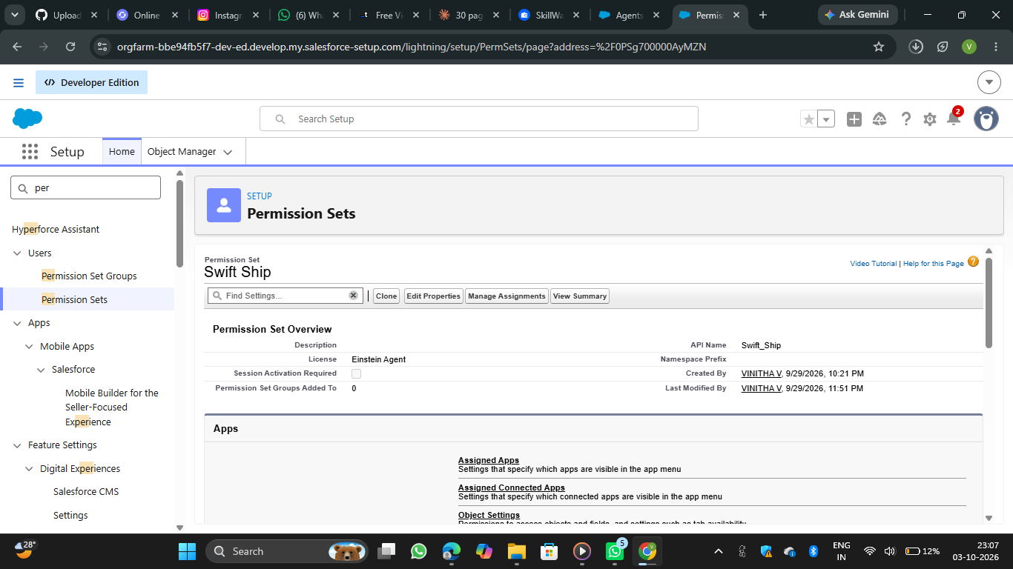
Figure 6: Permission set "Swift Ship" (License: Einstein Agent)
Inside the permission set, under Apps, Object Settings was opened and each object was selected one by one. After clicking Edit, the object permissions Read, Create and Edit were enabled (Delete is optional and was left unchecked), and Visible was checked for all key fields under Field Permissions. Save was clicked after each object.
Table 15: Object Permissions in the Swift Ship Permission Set
Object | Read | Create | Edit | Delete
Parcel__c | Yes | Yes | Yes | No
Delivery__c | Yes | Yes | Yes | No
Sender__c | Yes | Yes | Yes | No
Receiver__c | Yes | Yes | Yes | No

Milestone 2 - Assigning Permissions to your Agent User
In the Quick Find box, type Users and click Users under the Users section. From the list, the Einstein Service Agent user that represents the agent was opened by clicking its full name. Under Permission Set Assignments, Edit Assignments was clicked, the "Swift Ship" permission set was selected from the Available Permission Sets list, moved to the Enabled Permission Sets list using the Add button, and saved.

Milestone 3 - Org Setup for AgentForce
Enable the Salesforce default agent from Salesforce Go: from Quick Find, search Salesforce Go, search for Default Agent, click Get Started, turn it on and refresh the page.
Enable Einstein Setup: go to Setup, Quick Find, Einstein Setup, and click Get Started if prompted. Toggle on Turn On Einstein, Global Languages and Deploy Prompt Templates, then refresh the browser page.
Enable AgentForce Agents: go to Setup, Quick Find, AgentForce Agents, and toggle on Agentforce and Enable Agentforce Default Agent.

Milestone 4 - Building the Agent
In Setup, Agentforce Agents was searched in Quick Find, the default agent was opened and Open in Builder was clicked. A new subagent was created by clicking New, then New Subagent, with the description that the agent should give the parcel details related to the user by asking for the parcel ID. The subagent was named "Parcel Tracker", with the reasoning instruction: when the user asks parcel details giving a parcel ID, please show the parcel information.
Adding actions to Agentforce Assets: in the Agentforce Asset Library, Actions, New Agent Action was clicked. The action type Flow was selected and the recently created flow "Parcel Details" was chosen as the Reference Action, and the agent configuration details were filled in.
Assigning the action to the subagent: in Agent Builder, the Parcel Tracker subagent was opened, This Subagent's Actions was clicked, Add from Asset Library was selected, the flow action was ticked and Finish was clicked. In Settings, the agent was renamed to "Swiftship Tracker", saved, and activated using Ignore & Activate, then Activate.
Figure 7 shows the Parcel Tracker subagent with its reasoning instruction and the Parceldetails action. The agent is at Version 2 (Active) and Version 1 is committed.
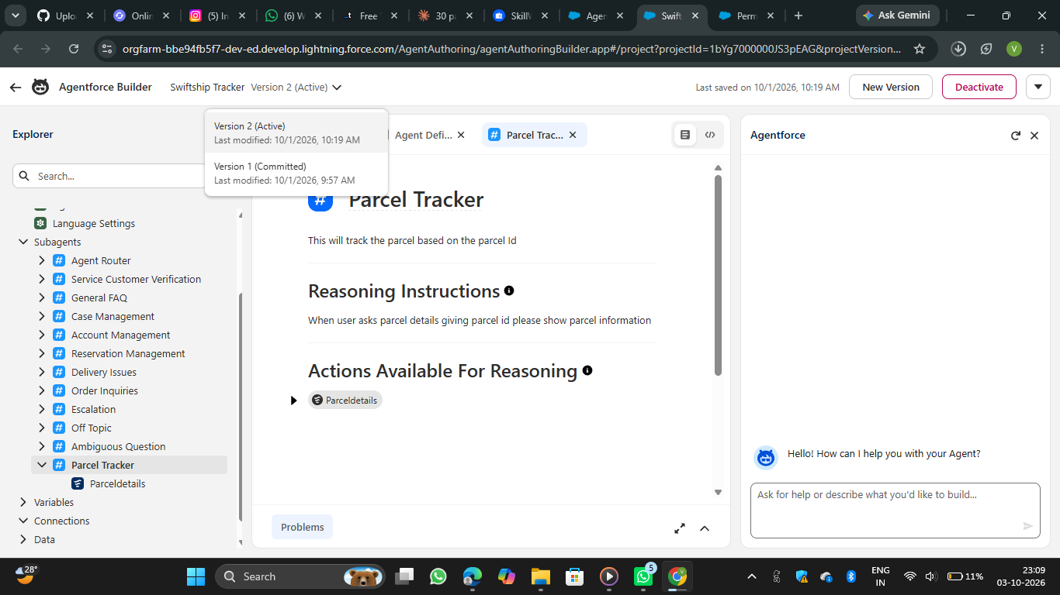
Figure 7: Agentforce Builder: "Parcel Tracker" subagent with the Parceldetails action

Phase 4: Data Migration, Testing & Security
This phase validates the functionality and reliability of the Parcel Tracking Agent created in Agent Builder. It ensures that the agent correctly recognises topics, triggers the assigned Flow, retrieves parcel data and performs all intended actions without access or permission issues. The goal is to confirm that the AI-driven agent operates seamlessly within Salesforce and provides accurate, real-time responses to parcel management queries.

Verify Agent
Go to Setup, Agentforce Agents, open the Agents list and confirm that the agent "Swiftship Tracker" appears and is active.

Validate Assigned Topic
In Agent Builder, Subagents, confirm that the subagent "Parcel Tracker" is listed. Open it to verify that it contains a description related to parcel management and that the Parceldetails flow action is linked to it. Save and ensure it is active (see Figure 7).

Check the Flow Association
Go to Setup, Flows. Locate the flow "Parcel Details" and confirm that it is Activated and that it handles Parcel ID input, parcel details retrieval and the response output. If data access is restricted, the flow can be run in System Context Without Sharing under Advanced Settings. Figure 8 shows the flow detail page.
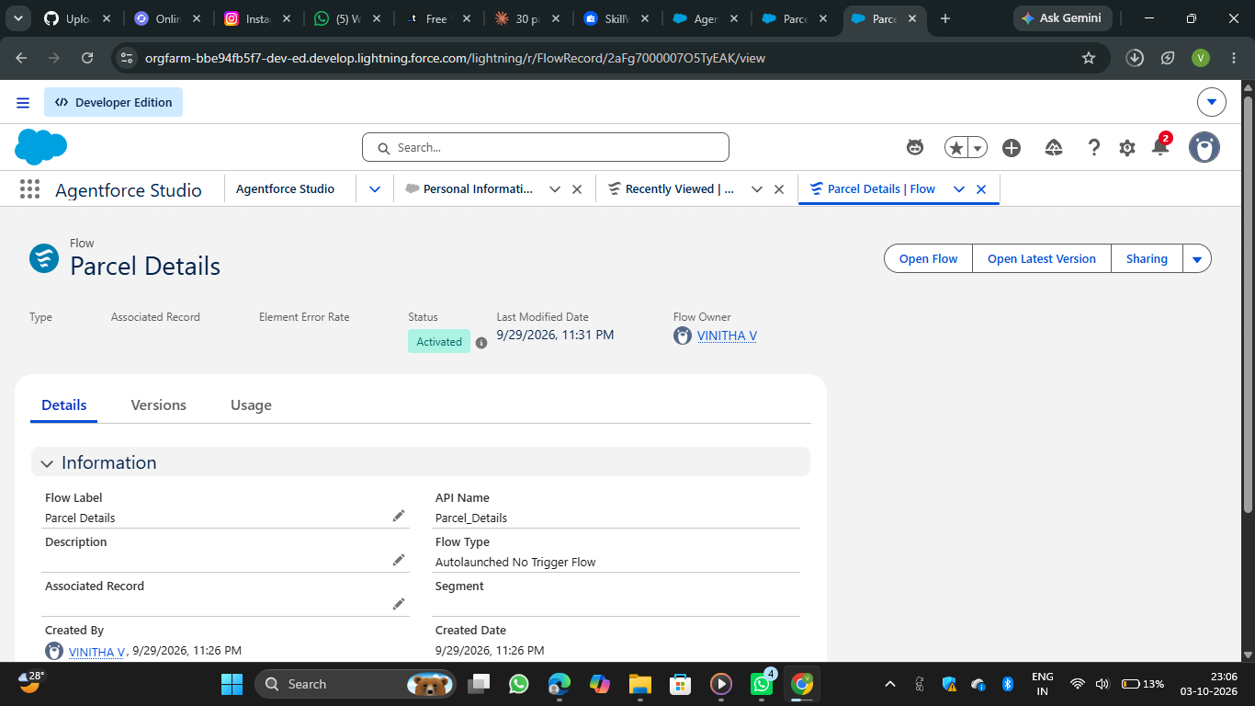
Figure 8: Flow detail page: Parcel Details (API name Parcel_Details, Activated)

Activate and Test the Agent
The agent was activated (if not already active) and tested using the Live Test preview of Agentforce Builder. The query "show the details of parcel id 2" was typed into the preview. Figure 9 shows the message that was sent.
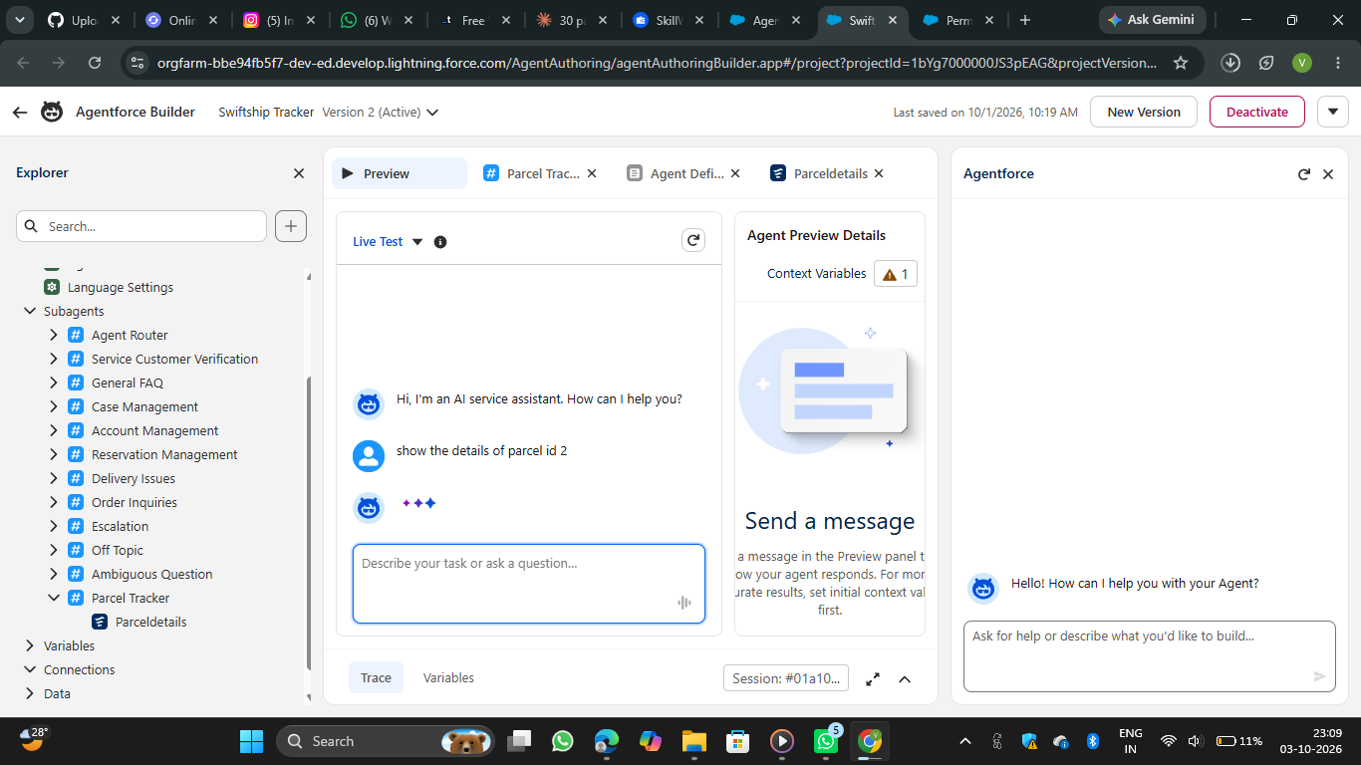
Figure 9: Live Test: user message "show the details of parcel id 2"
The agent then returned the details of the parcel. Figure 10 shows the response together with the execution trace on the right. The trace shows Transition to Subagent (Parcel Tracker), Reasoning, Action (Parceldetails), Reasoning and Output Evaluation, which is marked GROUNDED.
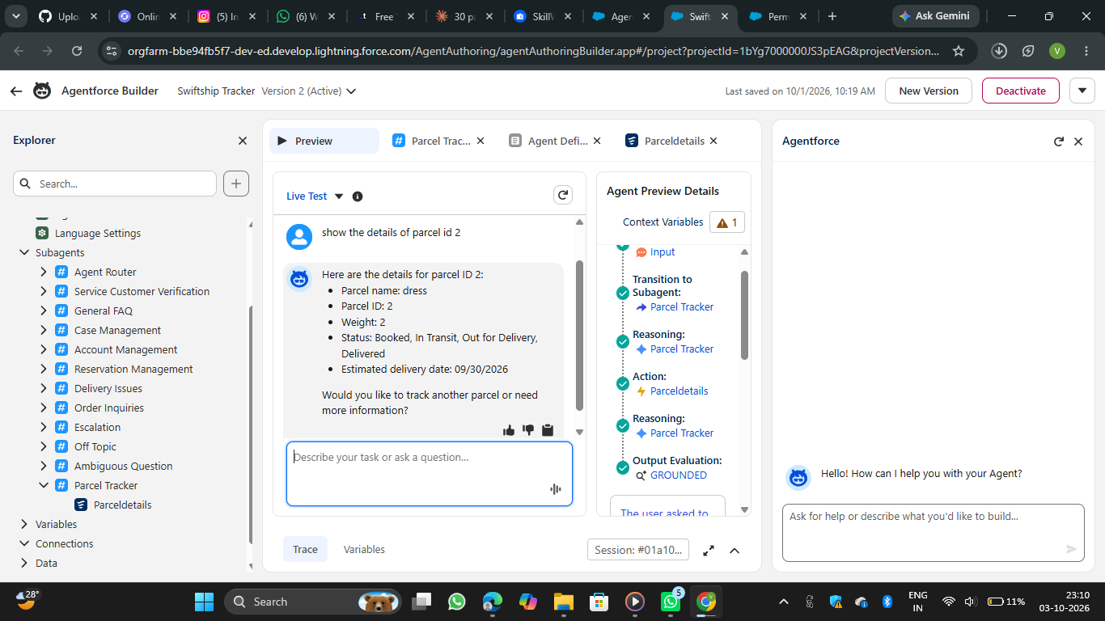
Figure 10: Live Test: agent response with the execution trace

Validate Data in Salesforce
After the agent runs the flow, the Parcels tab is opened from the App Launcher and the Parcel ID used during testing is searched. It is verified that the returned values (parcel name, weight, status and estimated delivery date) match the record in Salesforce.

Phase 5: Deployment, Documentation & Maintenance
In the scope of the SwiftShip Tracker (AgentForce) project implementation, the purpose of this phase is to validate that the Parcel Tracking Agent, created using Salesforce Agent Builder, works as intended within the Salesforce Developer Org environment. The main goal is to understand how an AI-powered service agent can be tested to ensure correct topic recognition, Flow execution and data retrieval from Salesforce custom objects.
Testing is conducted within the Developer Org to simulate how the agent would perform in a live setup, ensuring that permissions, flows and interactions function correctly before any deployment stage. Real-world production testing (UAT or sandbox deployment) is not performed in this project because:
- Developer Edition orgs are standalone environments and do not support production-linked testing environments.
- Enterprise-level AgentForce deployment involves sandbox testing, staging environments and CI/CD automation, which are outside the scope of this academic / prototype implementation.

Maintenance, Monitoring & Troubleshooting
In the SwiftShip Tracker (AgentForce) project, ongoing maintenance ensures that Parcel, Sender, Receiver and Delivery data remain accurate, synchronised and up to date. Regular monitoring helps detect issues such as misrouted agent queries, failed Flow executions or performance delays in AgentForce responses. Troubleshooting activities include resolving configuration errors, updating Flow logic, refining agent topics and improving prompts to enhance user interactions.
Although this project is implemented within a Salesforce Developer Org for learning purposes, in real-world enterprise deployments these maintenance and monitoring practices are essential. They ensure that AI-powered service agents remain reliable, scalable and continuously aligned with evolving customer service operations and business goals.

7. FUNCTIONAL & PERFORMANCE TESTING
During testing, screenshots were captured from Salesforce to validate the parcel object configuration, the Parcel Details flow, the Retrieve Parcel Details prompt template, the Swift Ship permission set and the Swiftship Tracker agent. All features were verified to ensure correct functionality and performance.
Table 16: Verification Checklist
Item verified | Where checked | Result
Parcel object deployed with field history enabled | Object Manager, Parcel details | Passed
Parcel fields created (Parcel ID, Estimated Delivery and others) | Object Manager, Fields & Relationships | Passed
Prompt template "Retrieve Parcel Details" is active | Prompt Builder | Passed
Flow "Parcel Details" is activated | Flows | Passed
Permission set "Swift Ship" created with Einstein Agent license | Permission Sets | Passed
Subagent "Parcel Tracker" linked to the Parceldetails action | Agentforce Builder | Passed
Agent version is active | Agentforce Builder | Passed (Version 2 Active)

Table 17: Functional Test Cases
Test ID | Input | Expected result | Actual result | Status
TC-01 | "show the details of parcel id 2" | Agent selects the Parcel Tracker subagent and calls the Parceldetails action | Subagent selected and action executed as shown in the trace | Pass
TC-02 | Parcel ID 2 | Parcel name, ID, weight, status and estimated delivery date are returned | Returned parcel name "dress", ID 2, weight 2, estimated delivery date 09/30/2026 | Pass
TC-03 | Response check | Response is based on Salesforce data | Output evaluation marked GROUNDED | Pass

Performance: the agent responded within a few seconds in the preview, which is acceptable for conversational tracking. Access worked correctly because the Swift Ship permission set had been assigned to the agent user.
Observation: in the response, the Status line lists all the picklist values (Booked, In Transit, Out for Delivery, Delivered) instead of only the current status. The prompt instructions can be refined so that only the current status is displayed. This is noted in the future scope.

8. ADVANTAGES & DISADVANTAGES

Advantages
- Centralised parcel and customer information in Salesforce.
- Provides better visibility into parcel booking and delivery tracking.
- Automates key logistics processes using Salesforce Flow.
- Agentforce enables conversational customer support and parcel-status assistance.
- Prompt Builder supports AI-powered responses and self-service.
- Reduces manual effort for customers, support teams and administrators.
- Provides timely notifications and updates during the delivery process.
- Experience Cloud can provide customers with convenient access to tracking information.
- Supports integration with external logistics systems.
- Can scale to support multiple locations and growing parcel operations.

Disadvantages
- Requires accurate and up-to-date parcel and customer data.
- Dependence on Salesforce configuration and automation.
- Agentforce responses depend on properly configured prompts and available data.
- External logistics integrations may increase implementation complexity.
- Flow and automation logic require regular maintenance when business processes change.
- Users need appropriate Salesforce or Experience Cloud access to use the system.
- Initial Salesforce implementation and configuration can require significant effort.
- Expanding the system to additional locations or integrations may require further customisation.

9. CONCLUSION
The SwiftShip Tracker demonstrates how Salesforce can be used to build a centralised parcel management and tracking solution. The project integrates custom objects, relationships, Flows, a Prompt Builder template, security controls and an Agentforce agent to support parcel booking, delivery tracking, status updates and customer communication.
The integration of AgentForce AI with Prompt Builder and Salesforce Flow provides a conversational approach to parcel tracking, enabling customers to obtain shipment information without depending entirely on manual support. The project therefore provides a practical foundation for a scalable and user-friendly parcel management solution.

10. FUTURE SCOPE
- Extend AgentForce capabilities for more parcel-management queries.
- Refine the prompt so that only the current parcel status is displayed.
- Enhance real-time delivery tracking.
- Expand customer self-service through Experience Cloud.
- Add more advanced delivery-performance analytics.
- Integrate additional external logistics systems.
- Improve AI prompts and conversational experiences.
- Introduce enterprise-level sandbox and CI/CD deployment.
- Expand automation for additional parcel operations.

11. APPENDIX
- A. Custom Objects: Parcel, Delivery, Sender, Receiver
- B. Standard Objects: Account, Contact, Case, Task, EmailMessage, User
- C. Automation: Flows, Approval Processes, Email Alerts
- D. Apex: Apex Classes, Batch Apex
- E. AI: AgentForce AI, Prompt Builder
- F. UI: Lightning App, Lightning Record Pages, Experience Cloud
- G. Security: Profiles, Roles, Permission Sets, Sharing Rules, Field-Level Security
- H. Analytics: Reports & Dashboards
- I. Testing: Flow, AgentForce, data retrieval, security and permission validation
Thank You

